
Building a
Customer 360 Analytics Framework

E Commerce Intelligent System – Project Report

MAY 2026

Authored by: Atanu Dutta Gupta

Table of Contents
Project Title: 3
Business Problem Statement 3
Dataset Description 4
Core Tables 4
Supporting Tables 4
Entity Relationship Diagram: 5
Methodology 6
Key Findings 7
Customers Dataset: 7
Sellers Dataset: 7
Orders and Revenue Analysis: 7
Category Analysis: 7
Delivery and Reviews Analysis: 8
State-wise Demand vs Supply: 8
Summary: 8
Business Insights 10
Visuals: 10
Sales Trend (Time Series): 10
Category Performance (Bar Chart): 10
Revenue (Histogram): 11
Outlier Detection (Box Plot): 11
Heatmap for Correlation Analysis: 12
Insights: 12
Recommendations: 14
References: 15

Project Title:
End-to-End E-commerce Intelligence System: Building a customer 360 Analytics Framework

Business Problem Statement
In modern e-commerce ecosystems, data is generated across multiple independent systems such as customer management, order processing, payments, product catalogs, seller networks, and customer feedback platforms. These datasets are typically fragmented and stored in separate tables, making it difficult to extract unified insights.
The objective of this project is to simulate a real-world data analytics scenario where you are required to:
- Integrate multiple data sources into a unified analytical dataset
- Construct a customer 360 View
- Analyze customer behavior, revenue patterns, and operational performance
- Identify key drivers of business growth and customer satisfaction
- Generate actionable, data-driven business recommendations
This project reflects how data analysts and data scientists work in real organizations, where raw data must be transformed into meaningful insights before applying machine learning models.

Dataset Description

We are dealing with a multi-table e-commerce dataset consisting of the following files.

Core Tables
- customers.csv
Contains customer demographic and location information
- orders.csv
Central table containing order lifecycle details (purchase, delivery, timestamps)
- order_items.csv
Contains product-level details for each order
- payments.csv
Payment information including type and value
- reviews.csv
Customer feedback and review scores

Supporting Tables
- products.csv
Product details and categories
- sellers.csv
Seller-level information
- geolocation.csv
Geographic information (optional for advanced analysis)
- category_translation.csv
Mapping of product categories to English names

Entity Relationship Diagram:
This ERD shows a simple ecommerce system where everything revolves around orders. Customers place orders, and each order can have multiple products using the order_item table. Payments and reviews are stored separately to track transactions and feedback properly. Overall, it is a clean and well-organized design that avoids data duplication.

It is a snowflake schema because some dimension tables (like products → category_translation and customers/sellers → location) are further normalized into multiple related tables instead of being kept as single flat tables like in a star schema.

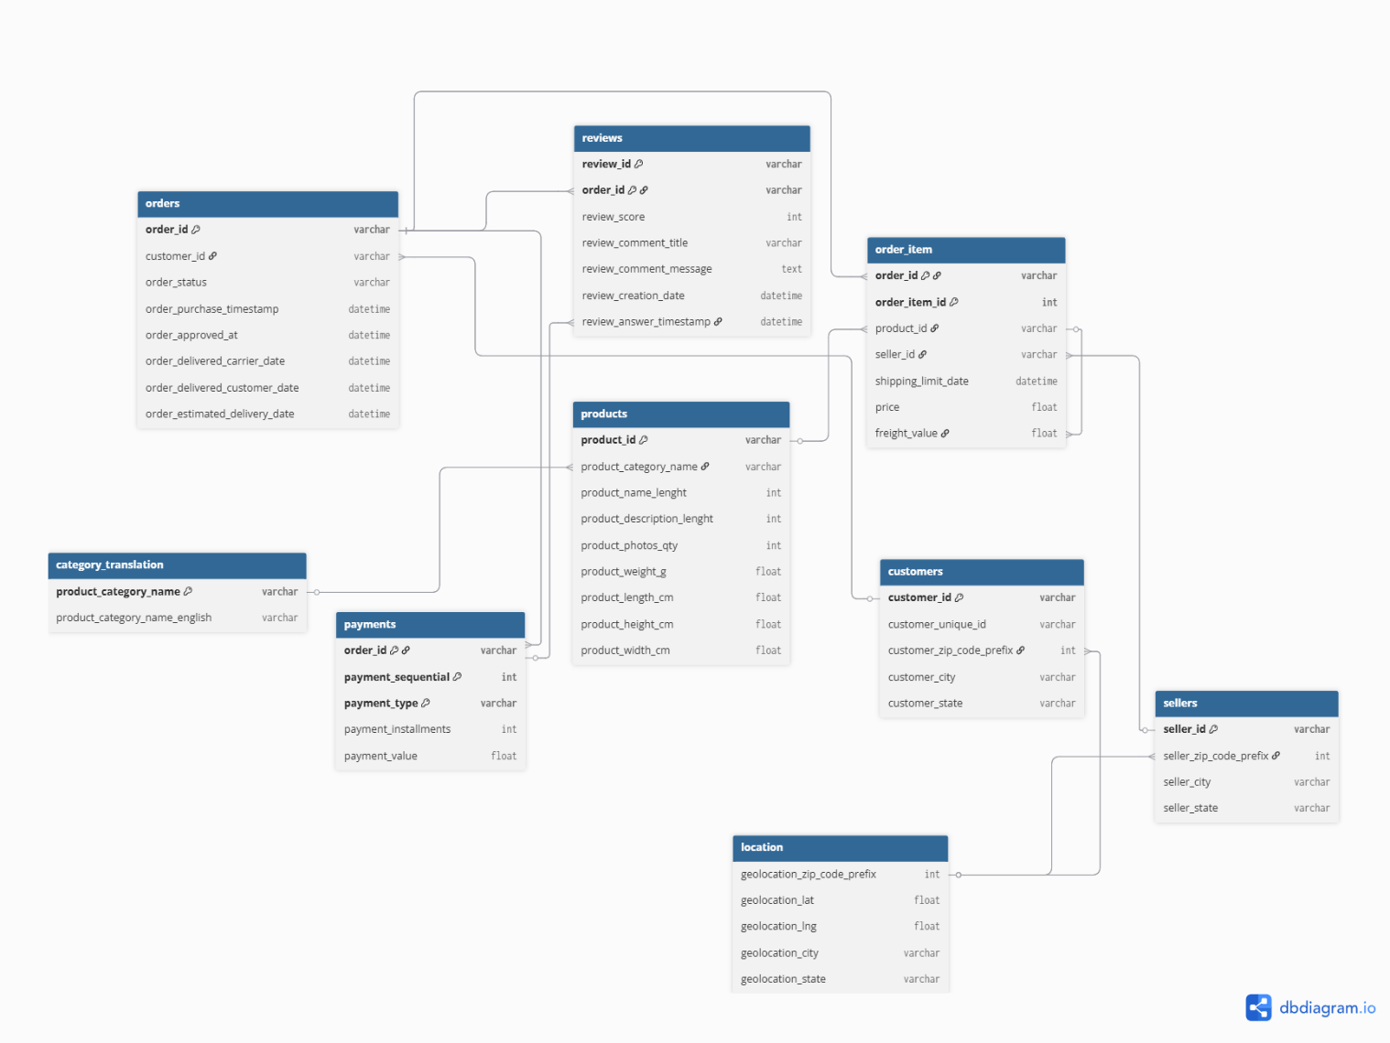

Methodology
- We have loaded all datasets using Pandas. Checked the structure using head(), info(), and describe().

- Next, we understood how different tables are connected and identified primary keys and foreign keys.

- Then, we cleaned the data by handling missing values. Also removed duplicate records to improve data quality.

- We converted date columns into datetime format. This helped in doing time-based analysis.

- We checked data types of all columns. Fixed any incorrect or inconsistent values.

- Next, standardized column names where needed. This made the dataset more consistent and easier to use.

- We merged multiple tables step-by-step. Created one master dataset for analysis.

- Created new features like total order value and delivery time. Also calculated number of items per order.

- Built customer-level metrics like purchase frequency. Also calculated average order value per customer

- Finally Prepared a Master dataset with complete business view. This includes customers, orders, products, and sellers.

- Next, we conducted exploratory data analysis (EDA) to identify key insights on the data. Also created important visuals to derive more insights.
- Finally, we have suggested strategies to improve business performance.

Key Findings

Customers Dataset:
- Customer distribution is highly concentrated in states like SP and RJ. This was observed from state-wise customer count analysis.
- Some states have significantly higher customers compared to others. This indicates uneven demand distribution across regions.
- Customer location plays a key role in delivery and logistics performance. This is evident from state-level comparisons.

Sellers Dataset:
- Sellers are mostly concentrated in a few states like SP. This was identified using seller state-wise count.
- Several high-demand states have very few sellers. This creates a clear supply-demand gap.
- Low seller presence in certain regions leads to dependency on distant shipping. This impacts delivery efficiency.

Orders and Revenue Analysis:
- Revenue distribution is highly right-skewed with most orders in low-value range (₹0–150). This was observed from histogram and boxplot analysis.
- A small number of high-value orders form the long tail of revenue. These were visible as outliers in the boxplot.
- Monthly sales trend shows variation over time. This indicates possible seasonal demand patterns.

Category Analysis:
- A few product categories contribute majority of total revenue. This was identified from category-wise revenue bar chart.
- Many categories have very low contribution. This creates a long-tail distribution in product performance.
- Category-level analysis helps identify top-performing segments. This is useful for business focus.

Delivery and Reviews Analysis:
- Delivery time varies significantly across orders. This was calculated using delivery_time_days feature.
- Orders with longer delivery time tend to have lower review scores. This shows strong impact on customer satisfaction.
- Faster deliveries are generally associated with better ratings. This highlights importance of logistics efficiency.

State-wise Demand vs Supply:
- States like RJ, MG, and BA have high number of customers but very few sellers. This was derived from merged state analysis.
- This imbalance indicates strong demand but weak supply in these regions. It creates operational challenges.
- Balanced states like PR show better customer-seller ratio. This supports smoother operations.

Summary:
- The business operates on a high-volume, low-value model. Most transactions are small but frequent.
- Revenue is concentrated in a few categories and regions. This shows dependency on key segments.
- There is a clear geographic imbalance between customers and sellers. This impacts delivery performance.
- Delivery time is a major factor affecting customer satisfaction. Improving logistics can significantly improve ratings.
- Most customers are located in a few high-demand states. This makes regional strategy very important for growth.
- Seller distribution is not aligned with customer demand in many regions. This creates inefficiencies in order fulfilment.
- A small number of high-value orders contribute to overall revenue growth. These orders can be targeted for premium strategies.
- Customer behaviour shows preference for low-value purchases. This suggests price sensitivity and need for value-based offers.
- Payment patterns indicate strong preference for certain payment types. This can be used for targeted promotions and offers.
- Overall, improving logistics, balancing supply-demand, and focusing on top categories can drive better business performance.

Business Insights

Visuals:

Sales Trend (Time Series):
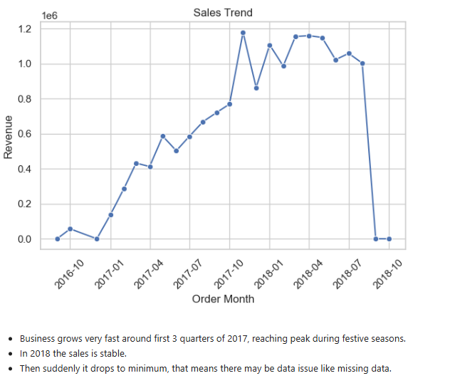

Category Performance (Bar Chart):
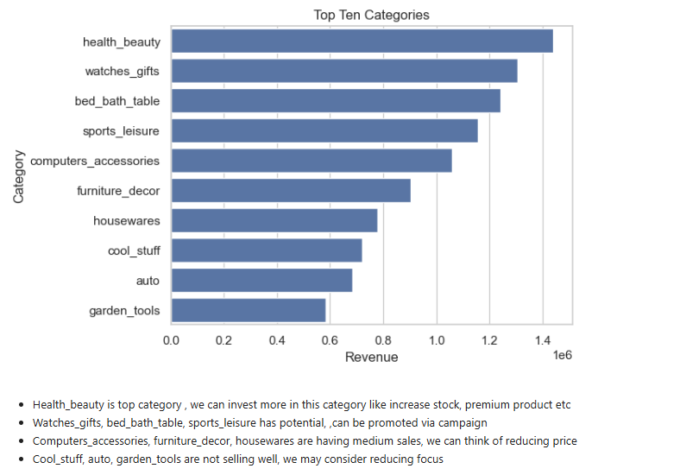

Revenue (Histogram):
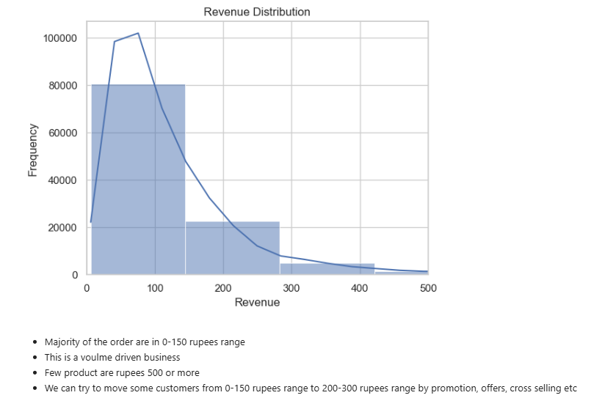

Outlier Detection (Box Plot):
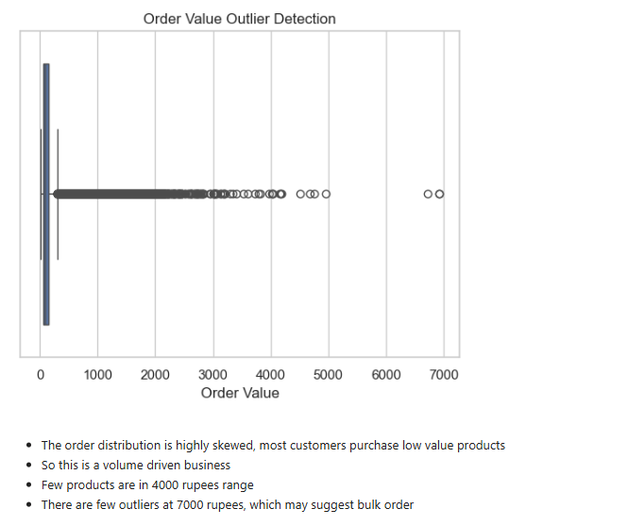

Heatmap for Correlation Analysis:

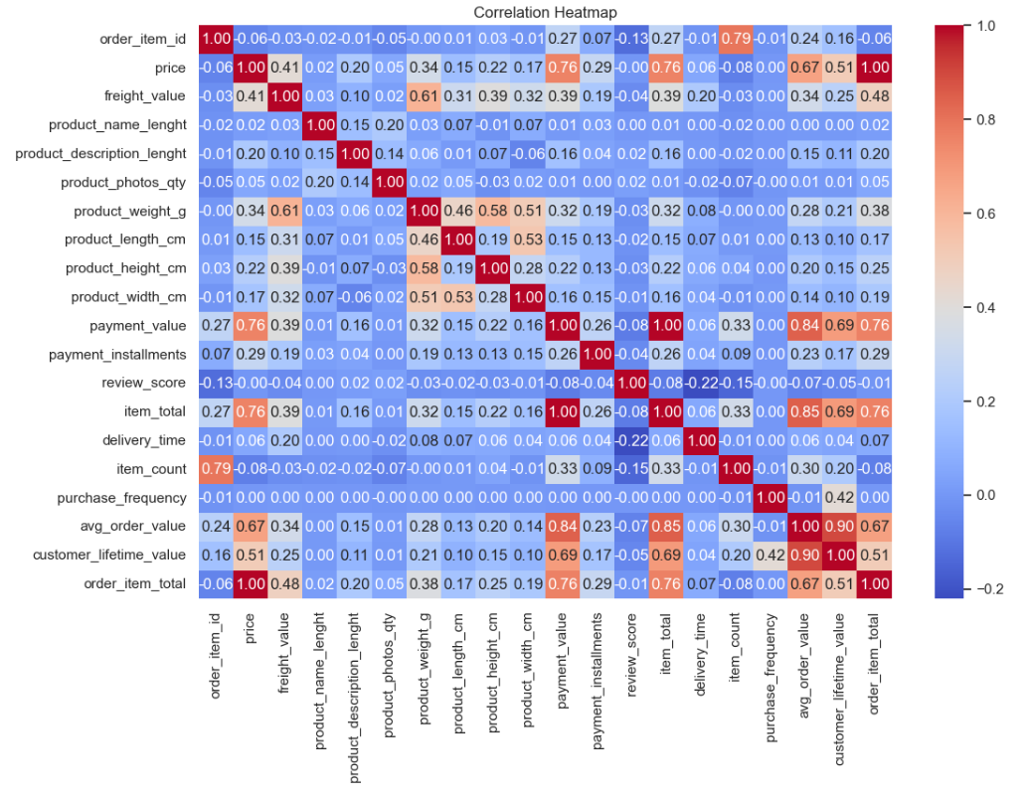

Insights:

- Revenue is mainly coming from a few top product categories. This shows the business is dependent on specific segments for growth.

- Most orders are low-value and fall in the ₹0–150 range. This indicates a high-volume, low-ticket business model.

- A small number of high-value orders contribute to overall revenue. These orders form the long tail and have strong impact.

- Customer demand is very high in states like SP and RJ. These regions are the key markets for the business.

- Seller presence is not evenly distributed across states. Some high-demand regions have very few sellers.

- There is a clear supply-demand gap in states like RJ, MG, and BA. This can lead to delivery delays and poor customer experience.

- Delivery time varies significantly across orders. Longer delivery time is associated with lower customer ratings.

- Faster deliveries generally result in better review scores. This shows logistics plays a key role in customer satisfaction.

- Customers prefer certain payment methods more than others. This reflects strong behavioral patterns in payment usage.

- Most orders contain fewer items. This indicates low basket size and opportunity to increase order value.

Recommendations:
- Focus more on top-performing product categories. These categories are already driving most of the revenue.
- Improve or rethink low-performing categories. This will help in better use of inventory and marketing efforts.
- Try to increase order value using combo offers and discounts. This will help move customers from low-value to mid-value purchases.
- Target high-demand states like RJ, MG, and BA for seller expansion. These regions have many customers but fewer sellers.
- Onboard more sellers in low-supply regions. This will reduce delivery time and improve customer experience.
- Improve logistics and delivery operations. Faster delivery will directly improve customer ratings.
- Monitor and reduce delivery delays using better planning. This will help avoid negative reviews and dissatisfaction.
- Identify high-value customers and give them special offers. This will help in customer retention and repeat purchases.
- Promote popular payment methods with offers and cashback. This can improve conversion and customer satisfaction.
- Use customer behavior data to create personalized recommendations. This will help increase engagement and sales.

References:
- Dataset:
- Project Guideline:
- Jupyter Notebook:
- Visuals:

